实验12 TestDirector实战

|  |  |  |  |  |  |  |  |
| --- | --- | --- | --- | --- | --- | --- | --- |
| 组 别 |  | 实验人员 | KAFLE SAMRAT | | | | |
| 实验项目名称 | TestDirector实战 | | | | | | |
| 实 验 类 别 | 验证型□ 设计型□ 综合型□ | | | | | | |
| 实 验 工 具 |  | | | 实验地点 | J13-132 | 实验日期 | 2020.12 |
| 学生实验小结 | TestDirector测试能够分析实验方案设计的合理性，发现的软件缺陷、分类和产生缺陷的原因等。 | | | | | | |
| 教师评语 | 指导教师签名：  年 月 日 | | | | | | |
| 实验成绩 |  | | | | | | |

要求标题要求黑体四号字体，正文为宋体小四号字体。内容模板如下所示。

1实验内容和目标

1.1实验内容

本实验主要结合上次实验，通过模拟测试一个项目，掌握对TestDirector的使用。

1.2实验目标

（1）掌握使用TestDirector创建测试项目

（2）掌握使用TestDirector管理测试过程

2实验方案设计

2.1实验环境

Windows server2003 虚拟机 TestDirector

2.2 实验原始数据

被测试的程序和有关文档。

2.3实验方法设计

选择的测试方法和设计的测试用例，自己编写的测试代码等。

3实验步骤和结果

Task 1: Create a test project using TestDirector

(1) Create the test project SE_Taobao

(2) Select MS Access database

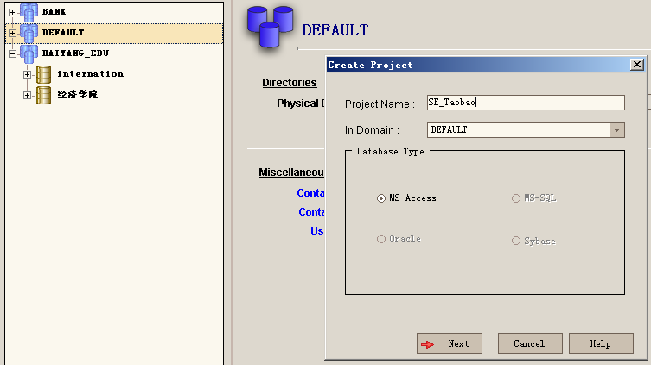

Task 2: Configure the project

1. Deploy developers and testers, etc., for the project SE_Taobao;

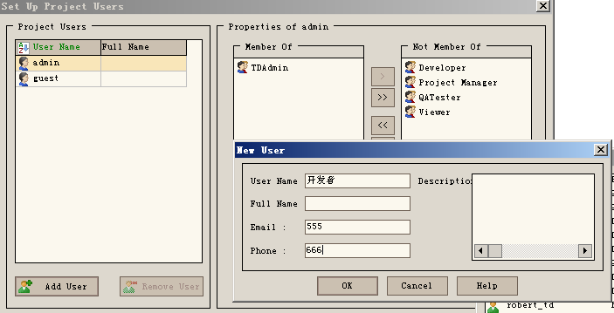

1. Configure user groups

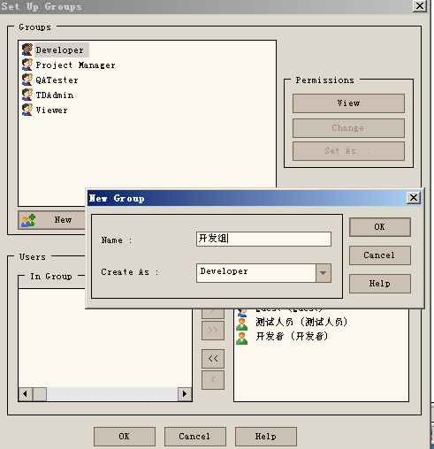

Create a User Group



Add a member to a user group

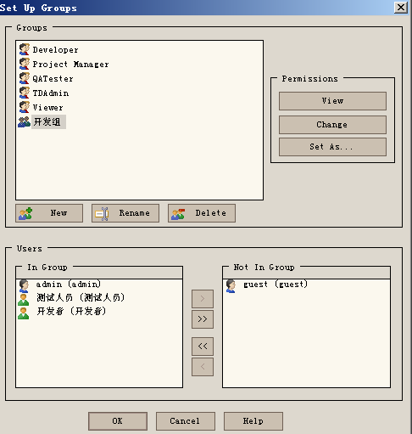

Assign permissions

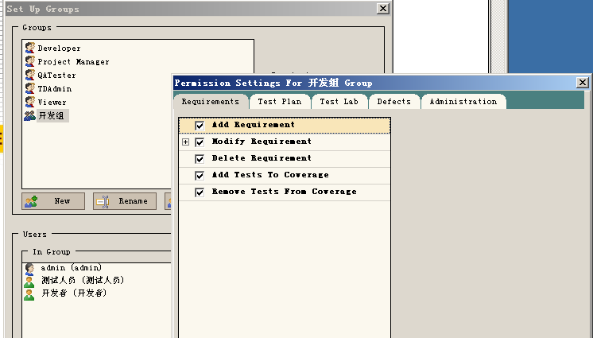

1. Customize the use module

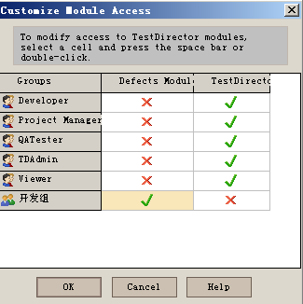

1. Custom defect field

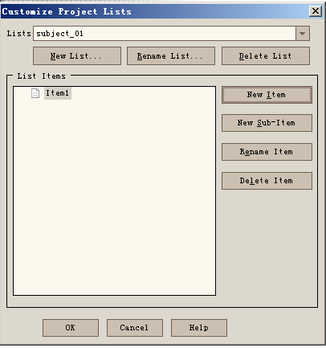

Task 3: Manage requirements

1. Create the requirements tree

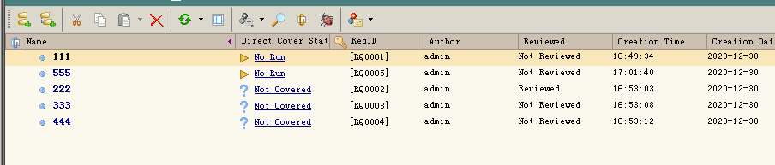

1. Test to establish correlation for requirements

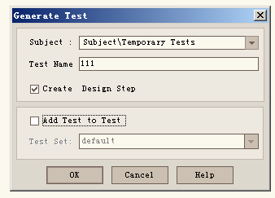

1. Look at defects associated with requirements

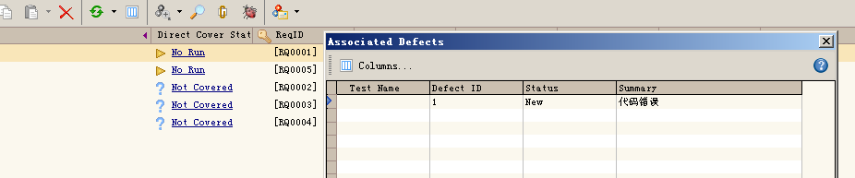

Task 4: Manage the test plan

1. Establish a test folder

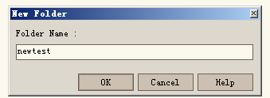

1. Set up the test plan in the folder

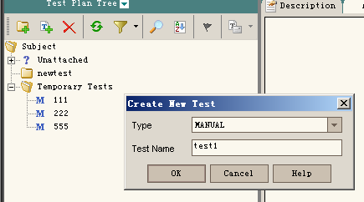

1. Add test steps

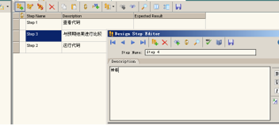

1. Select the requirements associated with testing

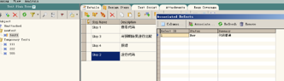

1. Relate the BUG to the test

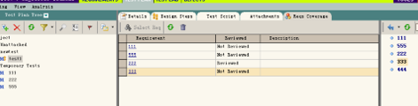

Task 5: Execute the test

1. Select the test from the test plan

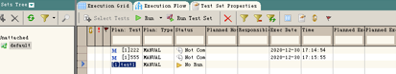

(2) Select any test to run

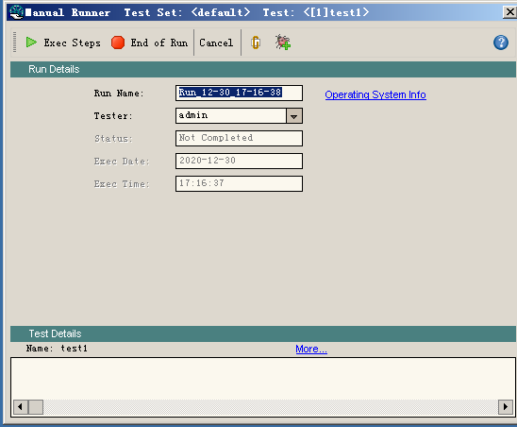

(3) Click Run to execute manual test

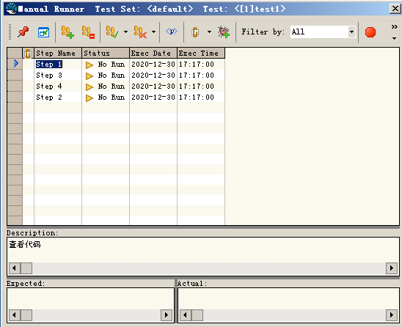

1. Click Run Test Set to execute the automatic Test



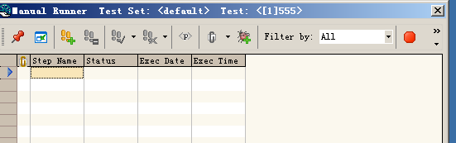

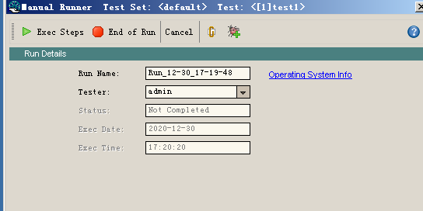

Task 6: Manage defects

1. Add defects
2. Check whether there are similar defects

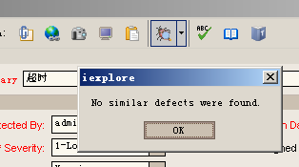

1. Check the tests associated with the defect
2. Set defect interface, etc

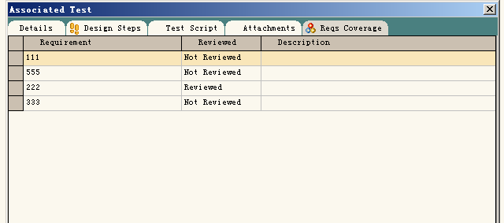

4实验结果分析

TestDirector testing can analyze the rationality of the experimental design, the software defects found, the classification and the cause of the defects, etc.